Paper Title (use style: paper title)
Sanfeng Zhang^{1,a}, Lianjie Li^{2,b} and Shifu Wang^{2,c}
¹School of xxx, yyy University, Beijing, China
²School of aaa, bbb University, Beijing, China
ªzhangsf@126.com, ^{b}lilianjie@hotmail.com, ^{c}wangshifu@163.com
Abstract. All manuscripts must be in English, also the table and figure texts, otherwise we cannot publish your paper. Please keep a second copy of your manuscript in your office. When receiving the paper, we assume that the corresponding authors grant us the copyright to use the paper for the book or journal in question. Should authors use tables or figures from other Publications, they must ask the corresponding publishers to grant them the right to publish this material in their paper.
Keywords: xxx xxx, xxx xxx
- INTRODUCTION
The first paragraph after a heading is not indented (Bodytext style). Other paragraphs are indented (BodytextIndented style).
All manuscripts must be in English, also the table and figure texts, otherwise we cannot publish your paper. Please keep a second copy of your manuscript in your office. When receiving the paper, we assume that the corresponding authors grant us the copyright to use the paper for the book or journal in question. Should authors use tables or figures from other Publications, they must ask the corresponding publishers to grant them the right to publish this material in their paper.
- ANOTHER SECTION OF YOUR PAPER
All manuscripts must be in English, also the table and figure texts, otherwise we cannot publish your paper. Please keep a second copy of your manuscript in your office.
When receiving the paper, we assume that the corresponding authors grant us the copyright to use the paper for the book or journal in question. Should authors use tables or figures from other Publications, they must ask the corresponding publishers to grant them the right to publish this material in their paper.

Subsection
When receiving the paper, we assume that the corresponding authors grant us the copyright to use the paper for the book or journal in question. Should authors use tables or figures from other Publications, they must ask the corresponding publishers to grant them the right to publish this material in their paper.
1) Three Level Title
The paragraph text follows on from the subsubsection heading but should not be in italic. When receiving the paper, we assume that the corresponding authors grant us the copyright to use the paper for the book or journal in question. Should authors use tables or figures from other Publications, they must ask the corresponding publishers to grant them the right to publish this material in their paper.
2) Three Level Title
c₂ = a₂ + b₂ (1)

Page Numbers
All manuscripts must be in English, also the table and figure texts, otherwise we cannot publish your paper. Please keep a second copy of your manuscript in your office. When receiving the paper, we assume that the corresponding authors grant us the copyright to use the paper for the book or journal in question. Should authors use tables or figures from other Publications, they must ask the corresponding publishers to grant them the right to publish this material in their paper.
- ORGANIZATION OF THE TEXT
All manuscripts must be in English, also the table and figure texts, otherwise we cannot publish your paper. Please keep a second copy of your manuscript in your office. When receiving the paper, we assume that the corresponding authors grant us the copyright to use the paper for the book or journal in question. Should authors use tables or figures from other Publications, they must ask the corresponding publishers to grant them the right to publish this material in their paper. As show in Fig. 1 and Table 1, three scheme comparing.
References are cited in the text just by square brackets [1]. Two or more references at a time may be put in one set of brackets [3, 4]. The references are to be numbered in the order in which they are cited in the text and are to be listed at the end of the contribution under heading references, see our example below.

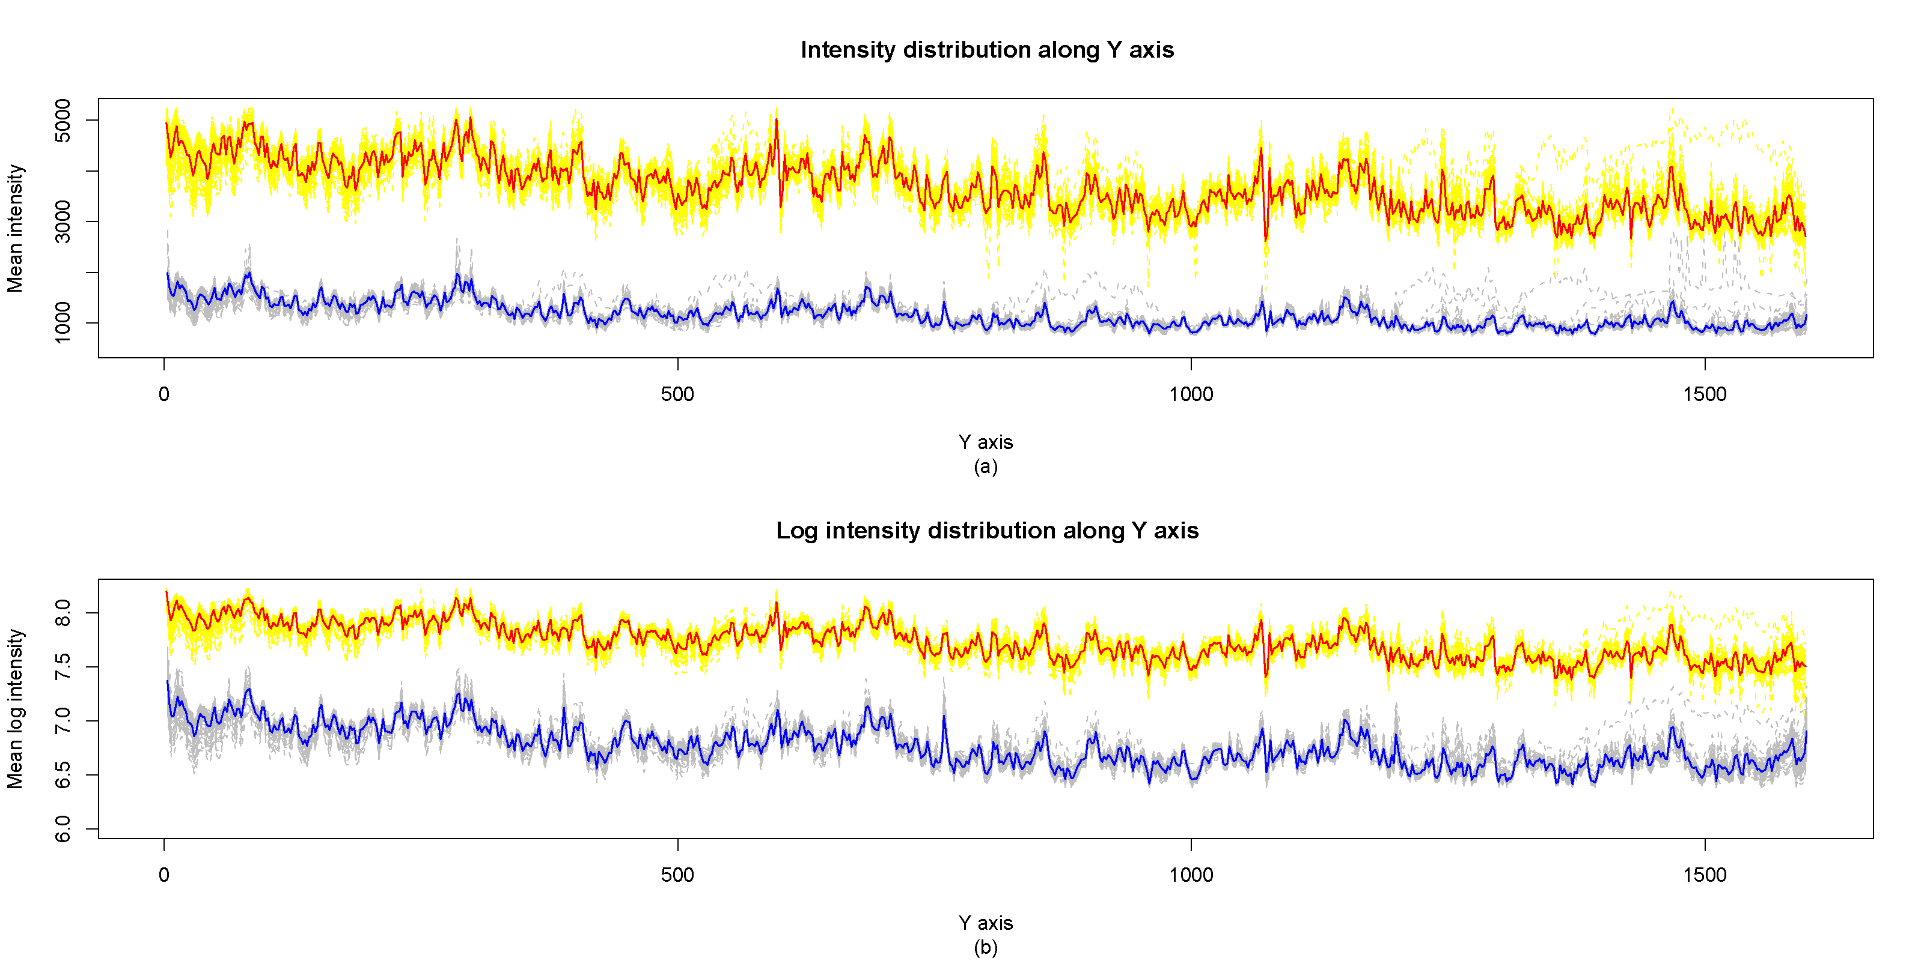
Figure 1. Two or more references.
All manuscripts must be in English, also the table and figure texts, otherwise we cannot publish your paper. Please keep a second copy of your manuscript in your office. Please keep a second copy of your manuscript in your office. When receiving the paper, we assume that the corresponding authors grant us the copyright to use the paper for the book or journal in question. Should authors use tables or figures from other Publications, they must ask the corresponding publishers to grant them the right to publish this material in their paper.
Please keep a second copy of your manuscript in your office. When receiving the paper, we assume that the corresponding authors grant us the copyright to use the paper for the book or journal in question. Should authors use tables or figures from other Publications, they must ask the corresponding publishers to grant them the right to publish this material in their paper.

Table 1. Three Scheme comparing.
Numble | Scheme 1 | Scheme 2 | Scheme 3 | Scheme 4 | Scheme 5
1 | 456 | 456 | 123 | 123 | 123
2 | 789 | 213 | 644 | 644 | 644
3 | 213 | 654 | 649 | 649 | 649
All manuscripts must be in English, also the table and figure texts, otherwise we cannot publish your paper. Please keep a second copy of your manuscript in your office. When receiving the paper, we assume that the corresponding authors grant us the copyright to use the paper for the book or journal in question. Should authors use tables or figures from other Publications, they must ask the corresponding publishers to grant them the right to publish this material in their paper.
- CONCLUSION
All manuscripts must be in English, also the table and figure texts, otherwise we cannot publish your paper. Please keep a second copy of your manuscript in your office.
When receiving the paper, we assume that the corresponding authors grant us the copyright to use the paper for the book or journal in question. Should authors use tables or figures from other Publications, they must ask the corresponding publishers to grant them the right to publish this material in their paper.
ACKNOWLEDGMENTS
This work was financially supported by xxx fund.
REFERENCES
- J. van der Geer, J.A.J. Hanraads, R.A. Lupton, The art of writing a scientific article[J], J. Sci. Commun. 2020, 163 (1): 51-59.
- Murashige S. Chaotic Roll Motion of a flooded ship in Regular beam waves[C]. The 4th Proceedings of the Experimental Chaos conference, 1997, 349-354.

